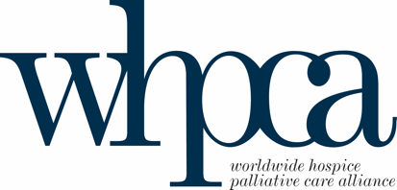

CONCEPT NOTE ON ESTABLISHING A FUND FOR PALLIATIVE CARE IN LMICs IN PARTNERSHIP WITH THE UN HEALTH4LIFE FUND (NCDS AND MENTAL HEALTH)

Palliative care is one of the key solutions to problems in health care systems around the world. The World Health Organization defines palliative care as “an approach that improves the quality of life of patients and their families who are facing the problems associated with life-threatening illness through the prevention and relief of suffering by means of early identification and correct assessment and treatment of pain and other problems, whether physical, psychosocial or spiritual.”

In 2014 the World Health Assembly unanimously passed a resolution on palliative care calling on all countries to “Strengthen Palliative Care as a Component of Comprehensive Care Throughout the Life Course.” However, since that time little progress on palliative care development has occurred and in some ways access to medicines and palliative care have fallen backward, especially in low and middle-income countries (LMICs)

The access abyss to palliative care globally is predominately in low and middle-income countries. Close to 50% of the need for palliative care in high-income countries is being met while only about 4% of the need is being met in LMICs. The most recent estimate of the need for palliative care in LMIC’s is 49.5 million, with only about 2 million receiving care. In addition, the World Health Organization, and the International Narcotic Control Board estimate that 80% of the World’s population, mainly in LMICs, suffers from complete lack of or extremely limited access to opioids for pain relief. As the Special Rapporteur on torture and other cruel, inhuman or degrading treatment or punishment has said denial of pain treatment by governments is unacceptable. 150 countries representing 83% of the world population lacks access to opioids for treatment of moderate to severe pain.

A mechanism for funding the development of palliative care globally is needed to help address these major healthcare disparities and to ensure that the most seriously ill experiencing the most serious health related suffering get the care they desperately need from diagnosis to end-of-life. How we do this is the first challenge to address. There are three international charitable organizations that advocate for palliative care with all the UN agencies, the Worldwide Hospice Palliative Care Alliance (WHPCA), the International Children’s Palliative Care Network (ICPCN), and the International Association for Hospice and Palliative Care (IAHPC). The WHPCA and IAHPC are both in official relations with the World Health Organization and in consultation with UN ECOSOC, and ICPCN soon will be. We collectively represent the palliative care movement globally.

WHPCA is a small INGO that is an alliance of the major regional and national palliative care organizations and associations globally. Our 500 organizational members from 103 countries include all four regional palliative care organizations 1) European Association of Palliative Care, 2) The African Palliative Care Association, 3) The Asia Pacific Hospice Palliative Care Network, & 4) Latin American Palliative Care Association. In addition, most of the national organizations in LMICs are represented. WHPCA board trustees are from Australia, Botswana, Brazil, Canada, Columbia, Egypt, Hungary, India, Ireland, Japan, Malaysia, UK, Uganda, and the USA. We also work when funding is available to help develop indigenous culturally grounded cost-effective models of palliative care delivery in countries including Bangladesh, Ethiopia, Kenya, Ukraine, Central Asian countries, and so forth.

Why is a ‘fund’ for palliative care needed? Access to primary palliative care, relief of serious health related suffering, human dignity, and decent care are all human rights issues. But why should funders care? The world has many pressing health care problems. The better question is what is the impact of not having palliative care and why do we allow millions to suffer and die unnecessarily? The evidence base for the positive impact of palliative care has grown significantly in recent years.

Whenever palliative care is compared to ‘standard care’ we see significant differences including 1) fewer unplanned and preventable hospitalizations and re-hospitalizations through proactive prevention of crises that result in unnecessary and non-beneficial care, 2) reduced symptom burden, 3) improved quality of life and better consumer evaluation of care received, 4) more goal concordant care, 5) poverty reduction and less out of pocket expenses, and 6) prevention of complicated or prolonged bereavement in surviving family members. In short palliative care improves the quality of health care and is cost-effective. Palliative care for cancer is now accepted by WHO as an NCD ‘best buy.’

In alignment with the primary pillars of the Health4Life Fund we see that palliative care would fit well with Integration and Health System Strengthening Pillars. A major focus of our efforts is to integrate palliative care mainly into primary care systems by delivering basic palliative care training into primary health care worker curricula. Also, for countries to integrate palliative care into existing health care systems there is a need for significant health system strengthening. Using the WHO public health model policies, research, access to essential medicines, education and training, and community involvement for integration need to be developed for palliative care to occur.

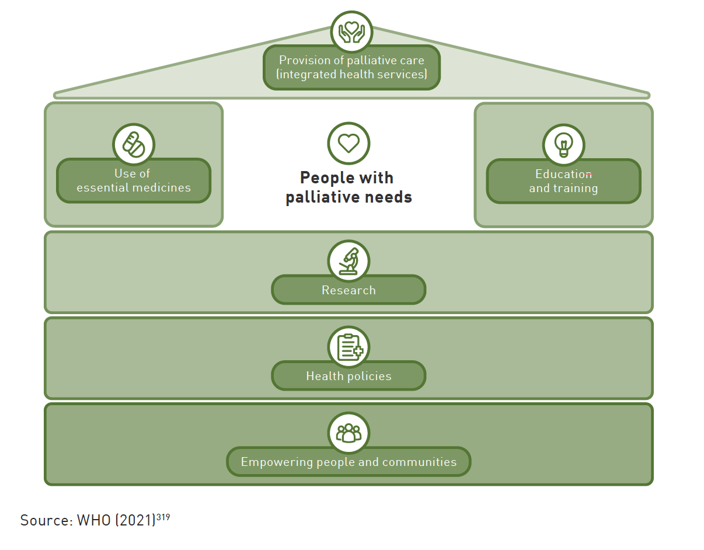

Theory of Change

The attached theory of change is a demonstration of how we envision that a window for Palliative Care in LMICs could be part of the Health4 Life Fund, including key assumptions, inputs, outputs, intermediate and long-term outcomes, achieving impact. Such a fund would need several high-income country supporters. Currently we have contacted Belgium, Australia, WHPCA is working on development of a coalition of member states supportive of palliative care. Also, many qualified partner organizations that would be on the ground implementers including educators, advocates, researchers, experts and policy developers. Most WHPCA/IAHPC/ICPCN organizational members are natural partners.

Palliative care is an essential component in the continuum of Universal Health Coverage (promotion-prevention-treatment-rehabilitation-palliative care) and a major aim of country-led efforts through multi-stakeholder grants provided by this fund would be to help ensure that palliative care is included as a covered benefit under UHC national plans and is part of national health insurance schemes that cover cancer care, mental health, pandemic preparedness, and so forth.

Furthermore, experience sharing between those entities engaging collectively within the palliative care window can be facilitated through the Health4Life Fund Learning Lab.

The palliative care INGOs as small charitable organizations do not have the infrastructure to manage the large funding facility that we are proposing. We would look to find a larger host organization that would manage the ‘GFPC-LMIC’ with technical support from WHPCA and partner organizations. The new Health4Life Fund currently housed with the UN Interagency Task force for NCDs is proposed as the most appropriate instrument. The concerned INGO partners may be invited to become Observers on the Health4Life Fund Steering Committee on a rotational basis. The core principles of the Fund as country-led, catalytic, participatory and inclusive are understood to be common across all Pillars and Windows including the proposed window for palliative care. The Fund’s operational guidance will be applied to the palliative care window with calls for proposals managed by the Secretariat, including technical support for final proposals that can be provided by the Health4Life Fund core team, other UN agencies and identified NGOs at the country level without prejudice to non-members of the INGO palliative care partners. Final decision on grant awards is made by the Health4Life Fund Steering Committee.

The unmet need for palliative care in LMICs appears overwhelming but these are primarily people with serious health conditions already in our health care systems and includes the impact on family and care givers. The world can’t afford to not have an effective mechanism to channel pooled funding for palliative care to -LMICs that supports effective, efficient evidence-driven palliative care health care models.

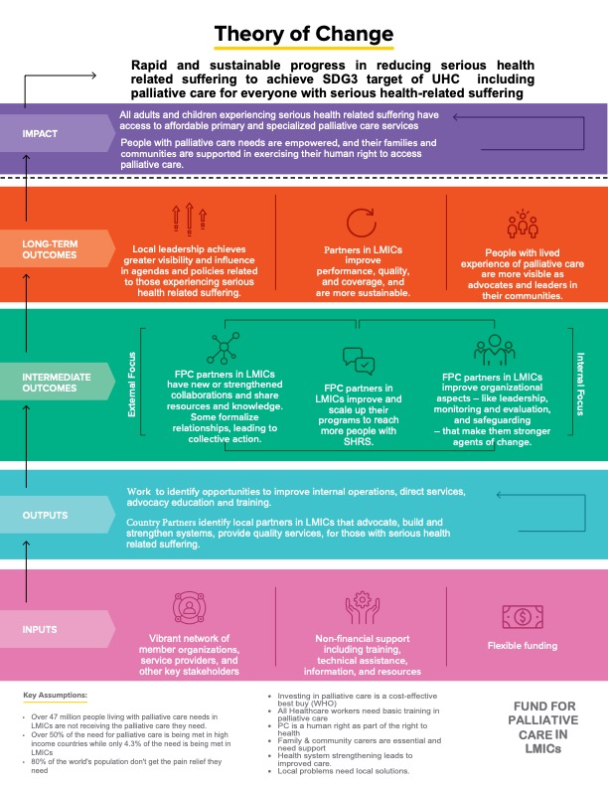

REFERENCES Connor S, Centeno C, Garralda MA, Clelland D, Clark D. (2021). Estimating the number of patients receiving specialized palliative care globally in 2017. J Pain Symptom Mgmt, 61(4):812-16.
International Narcotics Control Board. (2023). Availability of Internationally Controlled Drugs: Ensuring Adequate Access for Medical and Scientific Purposes - Indispensable, adequately available and not unduly restricted. https://www.incb.org/documents/Publications/AnnualReports/AR2015/English/Supplement-AR15_availability_English.pdf
Report of the Special Rapporteur on torture and other cruel, inhuman or degrading treatment or punishment, Juan E. Méndez https://www.ohchr.org/sites/default/files/Documents/HRBodies/HRCouncil/RegularSession/Session22/A.HRC.22.53_English.pdf
World Health Organization. (2024) Tackling NCDs: 'best buys' and other recommended interventions for the prevention and control of noncommunicable diseases, 2nd Ed. https://www.who.int/publications/i/item/9789240091078

